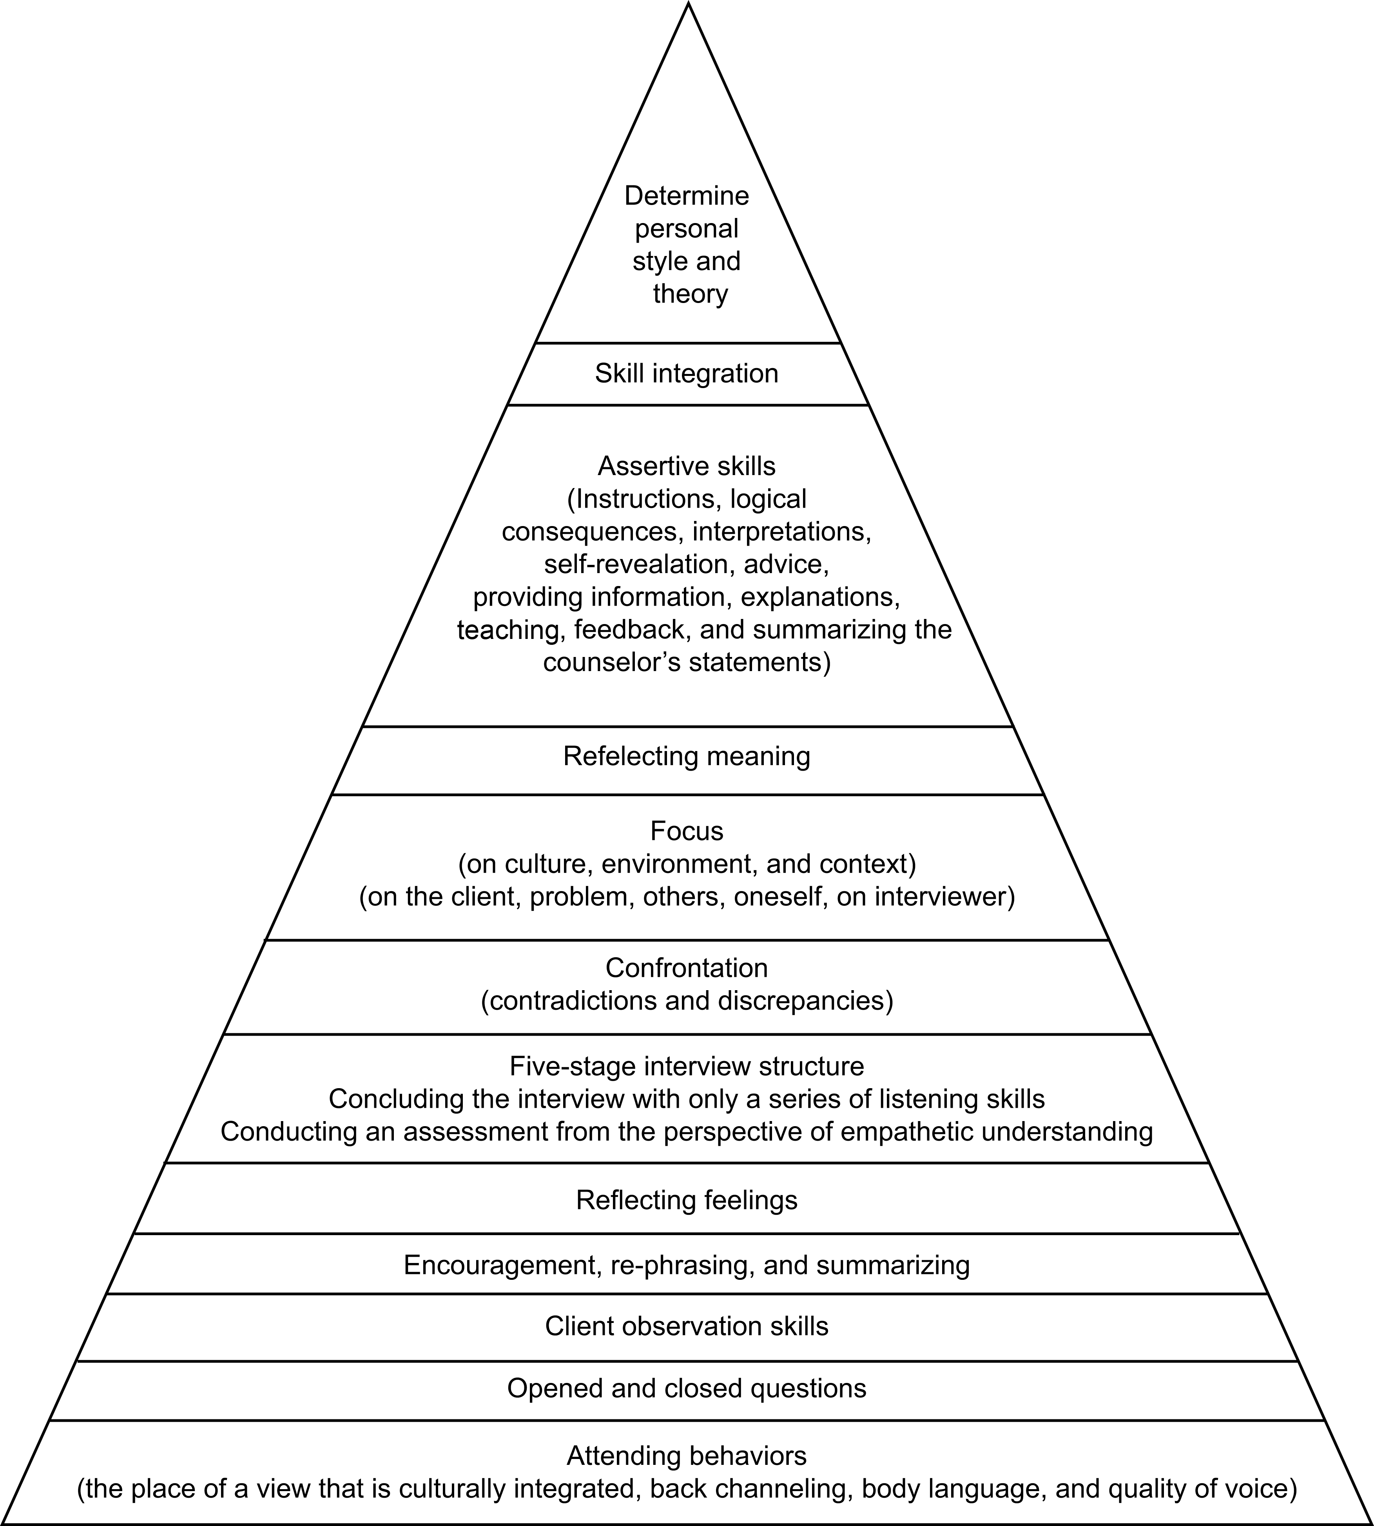
Fig S1: The hierarchical figure of micro-counseling skills (Ivey, 1995)
*Excerpts from Fukuhara and Allen (2004) Theory and Practice of Micro-counseling

Fig S1 legend
Fig S1 is the hierarchical figure of micro-counseling skills (Ivey, 1995).
＊Excerpts from Fukuhara and Allen (2004) Theory and Practice of Micro-counseling

